**District 6 Official Competitive Cheer Championship Clothing Information**

**Order Deadline December 1**

Congratulations on qualifying for the **District 6 Competitive Cheer Championships**. Recognize your team and build school and community excitement for your program by ordering your official District 6 Championship Apparel!

***BASIC UPDATED INFORMATION***

* D6 will not be selling clothing at District 6 Competitive Cheer Championships. All sales will be through this ordering process.
* All orders to be submitted via email on the D6 order form. Pictures of the form are acceptable as email attachments
* ***Both short sleeve and long sleeve t-shirts cost $15. This is not a misprint****.*
* ***There is a 15-item minimum for customization****.* There is a $1.00 charge per item for customization. Customization is wording only and on the back of shirt only. All customization must be the same on each customized item. Customization is limited school name and/or mascot name or a team slogan. Please specify color of ink to be used for the customization.
* ***ALL ORDERS WILL BE AVAILABLE AT HE CHAMPIONSHIP CONTEST SITE THE DAY OF THE CHAMPIONSHIPS***

***ORDERING PROCESS***

* Select an individual (AD, Coach, and Booster Representative to Coordinate the ordering for your **team**)
* Once all orders are received, the coordinator places all orders onto **one order form** and emails the form to the D6 Clothing Sales Chair Jody Rainey at [jrainey@homercenter.org](mailto:jrainey@homercenter.org) (See hints for best practice in order collection)
* Once order received, a confirmation of receipt of the order will be sent within 24 hours to the contact person whose name is on the order form. If confirmation not received within 24 hours call Jody Rainey at 724-388-7732.
* Once order is filled and ready for delivery, contact will be made and address of delivery will be confirmed.

***HINTS FOR ORDERING***

* If the sale for D6 clothing involves multiple groups (such as booster/parents, we suggest you gather the team order requests as one order, submit, and then have booster/parent leaders coordinate a group booster, parents and fan order and submit as a second order.
* We have found having each group submit their own group specific order form is easier for collection of orders, payment and distribution. This process is also easier for D6 to process and deliver the orders as well. D6 will have the team and booster orders separate for pick up at the Championship site.

**PAYMENT PROCESS**

* Orders can be submitted prior to payment.
* Once your order is received via email, a confirmation of order will be sent via email to the contact person listed on the order form. This confirmation will include confirmation of the total amount due. Please submit payment via US Mail to the address provided on the ordering form.

If you have any questions regarding District 6 Championship Apparel ordering, payments or related inquiries, contact Jody Rainey at (724) 479-8026 Ext. 3124 or at (724) 388-7732 or at [jrainey@homercenter.org](mailto:jrainey@homercenter.org)

Sizes (S, M, L, XL, XXL, XXXL, XXXXL) There is no additional charge for larger sizes.

***Add $1 per item for customization orders.***

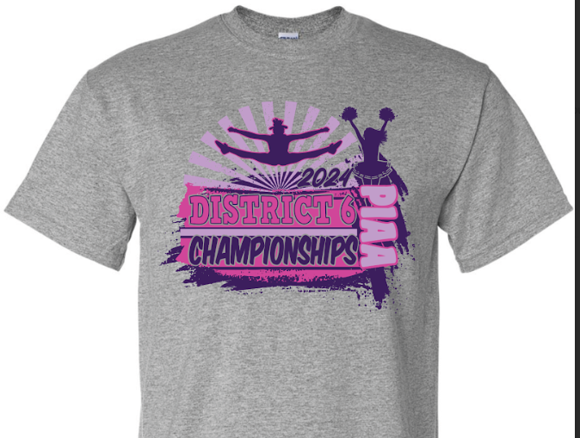

|  |  |  |
| --- | --- | --- |
| **Apparel Type** | **Non-Customized**  **Cost** | **Customized Cost** |
| **Short Sleeve**  **T-Shirt** | $15 | $16 |
| **Long Sleeve**  **T-Shirt** | $15 | $16 |
| **Crew Sweatshirt** | $20 | $21 |
| **Hoodie** | $25 | $26 |

*Send D6 order forms to jrainey@homercenter.org*